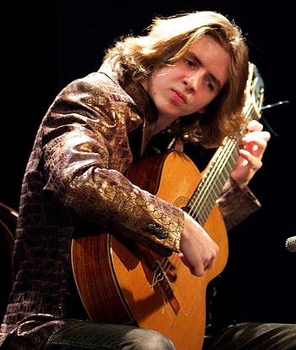
VIDEO CONCERT UNIVERSE SUITE
A unique coming together of guitar music and video-art.
Guitar music and video-art meld in the video concert of the Czech guitarist David Wurczel and the Dutch video-artist Ewout van Roon. A beauty of sound and images.

During the guitar performance by David Wurczel, Ewout van Roon will project video images on a large screen or white wall. The video concerts are suitable for the intimate atmosphere of a large living room to that of a concert space. The concerts usually last an hour, but can be adapted on request.

David Wurczel is a fantastic young guitarist and composer who has developed a ​​unique guitar technique which he has named Rotando. It is an interesting combination of the roterende rasgueado, classic tremolo and a ''orchestral style of guitar''.
Often sounding as if there are more guitarist playing along.
David has composed more than 15 pieces for solo guitar, which he performs during his concerts, together with diverse original arangements of famous compositions from the world of classical music, and also adaptations of gipsy swing genres and video game music.

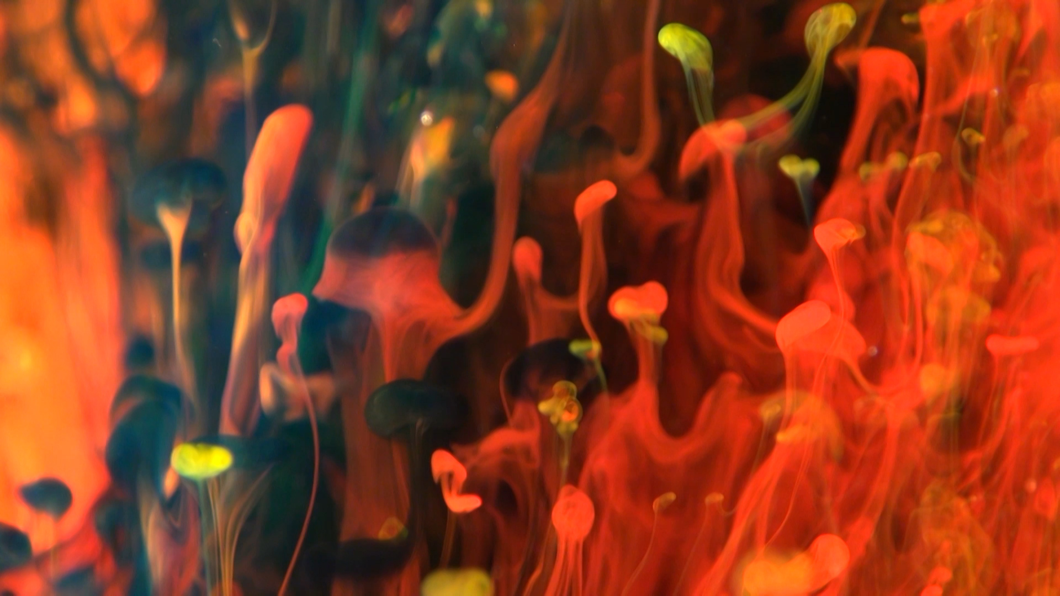
Ewout van Roon wishes to capture beauty and is fascinated by moving images. He creates painting-like films. Often inspired by nature or people. He has also made films that are created from a few droplets of ink in water. still from the film ‘Inkt (Ink)’

Trailer: www.ewoutvanroon.nl www.davidwurczel.com of
you tube: https://youtu.be/0oHeP4HiCcM
Info: info@ewoutvanroon.nl 06 53985104

